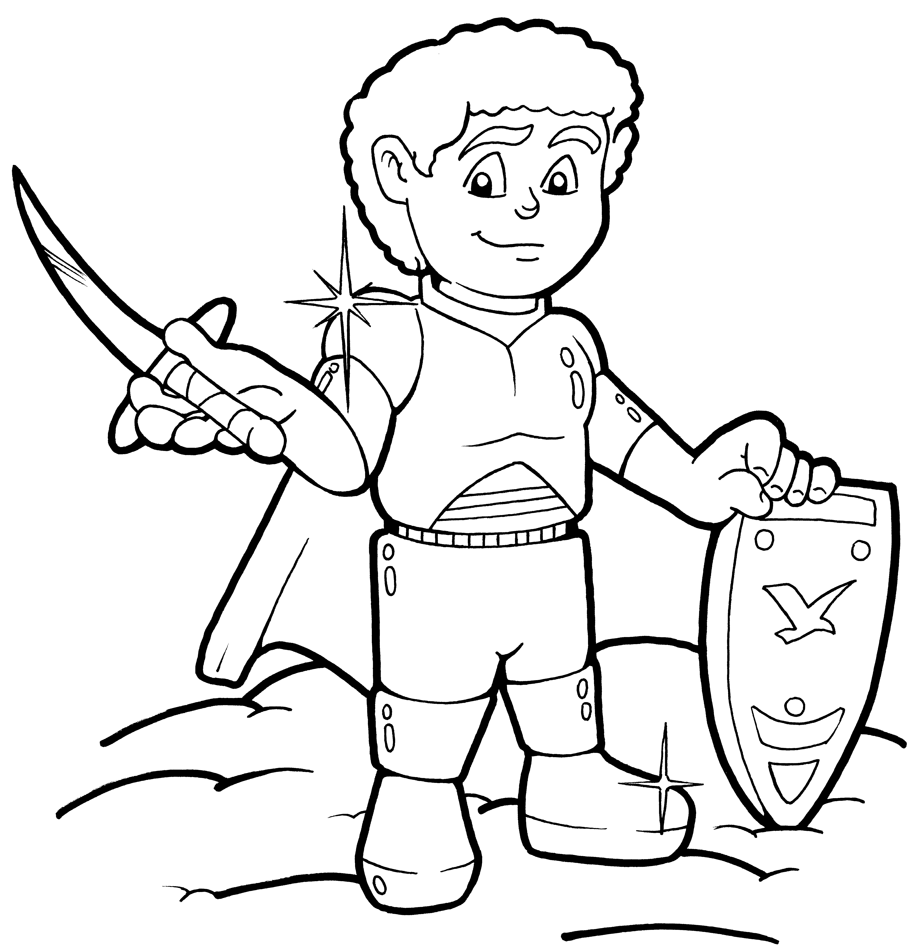

The Armor of God
EPHESIANS 6:10-11
“Finally, be strong in the Lord and in his mighty power. Put on the full armor of God so that you can take your stand against the devil's schemes”.
Schemes = tricks by lying

Just like a soldier does not go to battle unless he is fully covered and armed, we must take up the full armor to stand firm in the strength of the Lord from the Word of God.
Ephesians 6:13
Therefore put on the full armor of God, so that when the day of evil comes, you may be able to stand your ground…

6 parts of our Spiritual armor.
Ephesians 6:17 a
Take the helmet of salvation


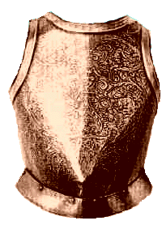

Ephesians 6:14 b
with the breastplate of righteousness in place.

Ephesians 6:14 a
Stand firm, with the belt of truth buckled around your waist,
Ephesians 6:17 b
and the sword of the Spirit, which is the word of God.


Ephesians 6:16
In addition to all this, take up the shield of faith, with which you can extinguish all the flaming arrows of the evil one.
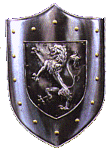

Ephesians 6:15
and with your feet fitted with the readiness that comes from the gospel of peace.
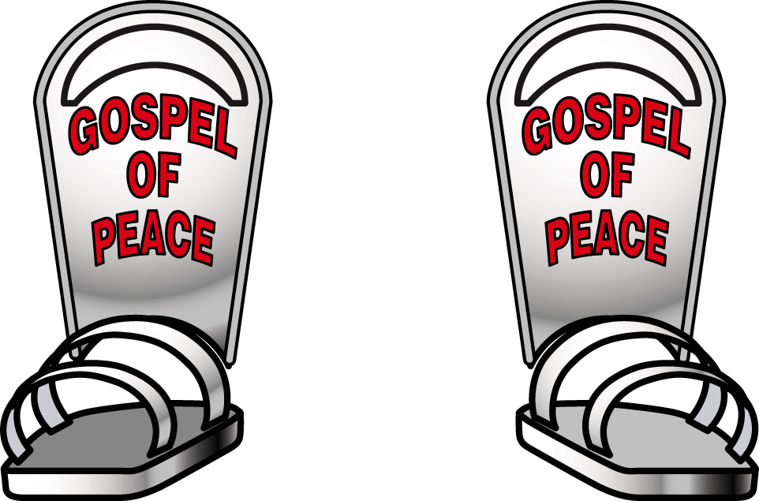

Match the piece of armor with the area of the body it protects on a soldier of Christ:
Belt of Truth Feet
Breastplate of Righteousness Head
Shoes of Peace Hand
Shield of Faith Front of whole Body
Helmet of Salvation Waist
Sword of the Spirit (Bible) Chest

When we put the armor on, we should pray all the time for all the saints.
Ephesians 6:18
And pray in the Spirit on all occasions with all kinds of prayers and requests. With this in mind, be alert and always keep on praying for all the saints.

Which piece of Armor is usually used to attack (Offensive) ? _ _ o _ _
Jesus used Bible verses to fight Satan when he was tempted.
What happens to a soldier who does not put on his Armor? He D _ _ S

Remember
Putting on the armor of God:
- Is a one time event when you accepted Jesus (helmet of Salvation = Eternal Life)
- Is a daily action reading the Bible, praying, obeying God’s Word.
- Helps us prepare for each day. We need to put on the Armor of God every day !
 How are you doing?
How many times have you put on your Armor this week.? 1, 2, 3, 4, 5, 6, 7
Did you avoid temptation by using the Bible as your sword this week? Yes, No.
Did you pray for all the saints this week? Yes, No.

EPHESIANS 6:10-11
“Finally, be strong in the Lord and in his mighty power. Put on the full armor of God so that you can take your stand against the devil's schemes”.
Schemes = tricks by lying

